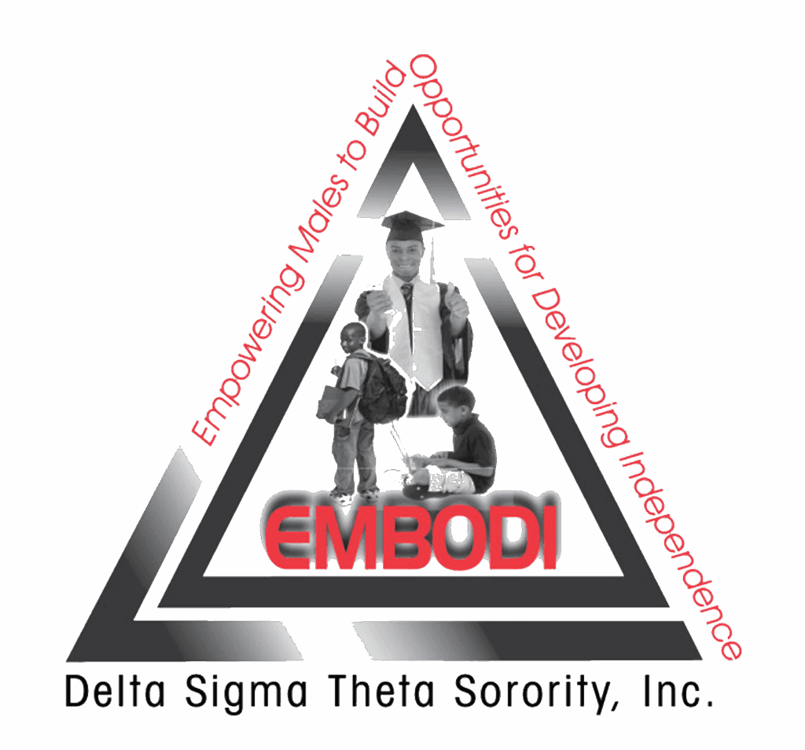

EMBODI Program Application
2026–2027 Academic Year
Empowering Males to Build Opportunities for Developing Independence
Young men ages 11–17 are invited to apply to the Kingstree–Lake City Alumnae Chapter EMBODI program. Through mentoring, hands-on activities and community service, participants will build confidence, leadership skills and practical tools for their future.

About the program
The proposed program runs from November 2026 through June 2027, with one in-person meeting each month from 10:00 a.m. to noon. Meeting dates, locations and orientation details will be provided by the chapter.
Participants will explore leadership and positive decision-making; money management; education and careers; professional skills; health and everyday life skills; and service to the community. Activities will support each participant’s age and stage of development.

How to apply
Complete all pages. A parent or guardian should complete the consent and recommendation sections. The applicant should write the short essay in his own words. Type directly in Word or print and write clearly. Sign where indicated.
□ Participant information □ Parent or guardian information and consent
□ Parent or guardian recommendation □ Applicant essay
Application deadline: _______October 15, 2026______________________________
Submit completed packet to: ____Kendra L. Wilson___________________________
Program contact and phone or email: _____president@klcalumnaedst.org________

Participant information
Please complete this page with help from a parent or guardian, if needed.
Full name

Date of birth: ____________________ Age: ______ Current grade: ______
School name

Mailing address including city state and ZIP code

Physical address if different

Applicant phone (if available): ___________________________________________
Applicant email if available

Preferred contact: □ Parent/guardian phone □ Parent/guardian email
□ Applicant phone □ Applicant email
How did you hear about EMBODI?

School church community or extracurricular activities

Skills hobbies and interests

Areas I would like to explore (check all that interest you):
□ Leadership □ Money management □ Careers □ College or training
□ Technology □ Life skills □ Community service □ Mentoring
□ Other: ______________________________________________________________

Parent or guardian information and consent
Applicant name: _______________________________________________________
Parent/guardian name: _________________________ Relationship: ___________
Phone: ____________________ Alternate phone: ___________________________
Parent or guardian email

Parent or guardian address if different from applicant

Emergency contact if parent/guardian cannot be reached:
Name: _________________________________ Relationship: _________________
Phone: ____________________ Alternate phone: ___________________________
Does your child have a health condition, allergy or support need that may affect participation? □ Yes □ No □ Prefer to discuss privately
If yes please briefly describe the support needed

Participation and emergency consent
I give permission for my child to participate in the KLAC EMBODI program for 2026–2027. I will help him attend scheduled activities and arrange transportation and timely pickup. I understand that drugs, alcohol, violence, abusive language and misconduct are not permitted, and I will pick him up promptly if asked for disciplinary reasons.
If an emergency occurs, I authorize the program leader or designee to seek medical attention for my child. I understand that the program will contact me as quickly as possible. Additional medical information and activity-specific permissions may be requested before participation.

Photography permission
Choose one: □ I grant □ I do not grant permission for my child’s photographs to be used in chapter program publicity, such as the website, newsletter or flyers, without compensation.
Parent/guardian signature: __________________________ Date: ______________
Applicant agreement: I will participate respectfully, follow directions and make a sincere effort to learn and contribute.
Applicant signature: _______________________________ Date: ______________

Parent or guardian recommendation
To be completed by the applicant’s parent or guardian. Please share what makes this young man unique and how EMBODI could support his growth. Brief responses are welcome.
Applicant name: _______________________________________________________
Parent/guardian name: __________________________________________________
What strengths or positive qualities does your child bring to the program?

How could mentoring leadership activities or life skills help your child?

Is there anything else you would like the committee to know? Optional

Parent/guardian signature: __________________________ Date: ______________

Applicant essay
Applicant name: _______________________________________________________
Tell us about yourself in 100–150 words. You may type or write your answer below. Use your own words; simple, honest answers are welcome. You do not need to attach a separate essay.

My goals and what I hope to learn
What is something you enjoy or do well? What is one goal you have for school, your future or your community? Explain how EMBODI could help you work toward that goal or learn a new skill.

Applicant signature: _______________________________ Date: ______________

